Name _____________________________ AP Calculus
7.2 Practice: Areas in the plane

Show all your work!
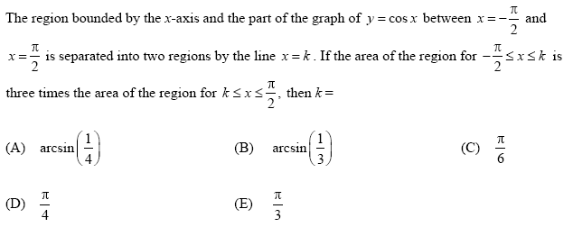
1.

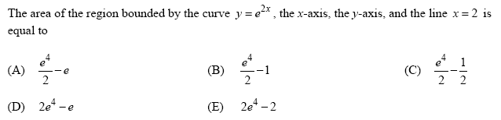
2.

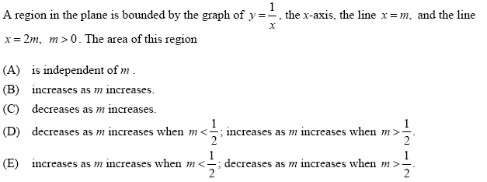
3.

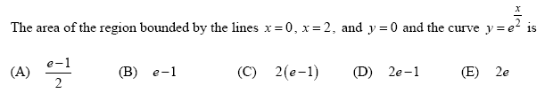
4.

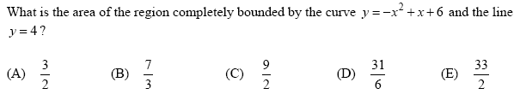
5.

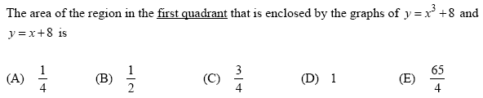
6.

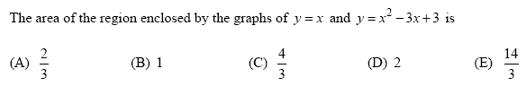
7.

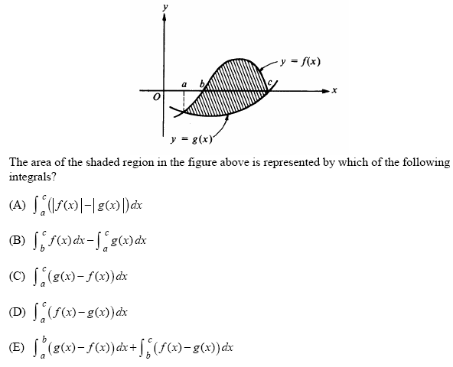
8.

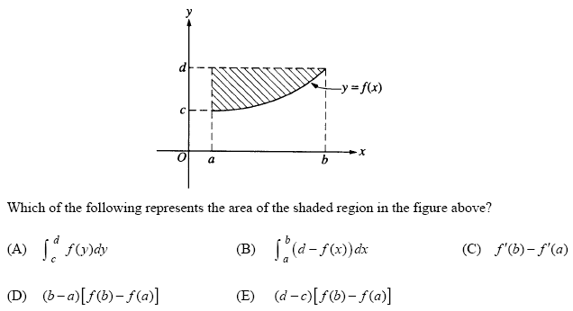
9.

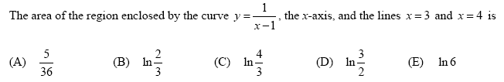
10.

